**Counterfeiting Detection System: A Solution to Combat Product Counterfeiting**

**ABSTRACT**

Counterfeiting is a severe economic and social issue, affecting both industries and the global market. The illicit trade in counterfeit brands poses a significant threat to the world economy, hindering the growth of brands in India and worldwide.

Fraudulent activities related to forgery and counterfeit products have surged across various industries in recent decades. This trend has left consumers struggling to differentiate genuine products from counterfeits. To combat this problem, a "Counterfeit Detection System" is proposed. This research paper explores the development and application of this system, focusing on its use in identifying counterfeit branded clothing.

The Counterfeit Detection System employs QR codes linked to a manufacturer's database. When consumers scan a QR code, the system validates the product's authenticity and alerts if the product has been sold before. This system enhances consumer trust, protects manufacturers, and ensures supply chain transparency.

While initially aimed at branded clothing, the system's principles can apply to various industries. This research paper emphasizes the importance of safeguarding consumers and businesses from counterfeit products in today's global marketplace.

**KEYWORDS**

Counterfeiting, Illicit trade, forgery, QR Code, authenticity validation, Global Marketplace.

**1. INTRODUCTION**

The Counterfeit Detection System is a vital web application designed to combat the pervasive issue of counterfeit clothing products. In a world where consumers often find themselves in a precarious position—uncertain whether the product they intend to purchase is genuine or a deceptive knockoff—this innovative solution emerges as a safeguard against fraud. The ramifications of unknowingly buying counterfeit goods are profound, leading to financial losses for consumers and tarnishing the reputation of authentic brands. For companies, the consequences include lost sales due to undercutting prices, erosion of brand integrity, strained relationships with business partners, and the need to allocate resources to combat counterfeiting.

Recognizing the urgency of this problem, the Counterfeit Detection System steps in to assist users in navigating this treacherous terrain. Its mission is clear: to empower consumers with the tools needed to make informed purchasing decisions and to eradicate counterfeit products from the marketplace. At its core, this web application leverages the innovative concept of QR code scanning, offering a seamless and efficient means of verifying product authenticity during the purchasing process.

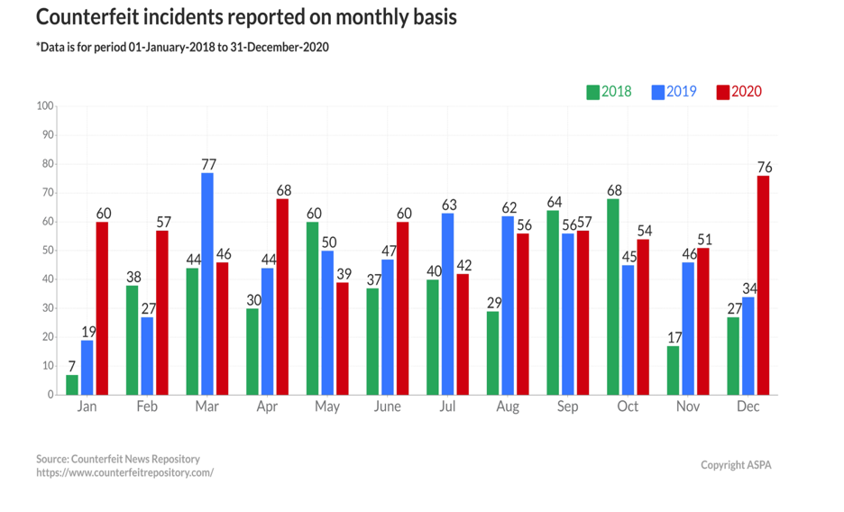

The Counterfeit Detection System is designed with a multi-faceted technological foundation, incorporating the prowess of Machine Learning, Front-End and Back-End web development, and a robust database. Machine Learning, a subset of Artificial Intelligence, plays a pivotal role in the system, enabling automated processes and decision-making without the need for manual human intervention.

On the web development front, React is harnessed for the Front-End, providing an intuitive and user-friendly interface that facilitates QR code scanning and the retrieval of product details. Meanwhile, Django powers the Back-End, managing the database, authentication, and the seamless flow of information.

In essence, the Counterfeit Detection System is not merely a web application; it is a beacon of hope for consumers and brands alike, illuminating a path toward a counterfeit-free shopping experience. It embodies the spirit of technological innovation harnessed for the greater good, safeguarding trust in commerce and ensuring that every purchase is a genuine one.

**2. LITERATURE REVIEW**

**2.1. Reason to work**

* **Economic Impact**: Counterfeiting in the clothing industry leads to significant economic losses for both legitimate brands and the overall economy. It results in reduced sales, profit margins, and market share for genuine clothing manufacturers. Moreover, counterfeit products are often sold at lower prices, negatively affecting the pricing structure and competitiveness of genuine brands.
* **Brand Reputation**: Counterfeit clothing products can harm the reputation and image of legitimate brands. Inferior quality and poor craftsmanship associated with counterfeit goods can lead to customer dissatisfaction and loss of trust in the genuine brand. This can have long-term consequences, affecting customer loyalty and brand loyalty.
* **Consumer Safety**: Counterfeit clothing items may not undergo proper quality control measures, resulting in substandard materials, hazardous dyes, and poor manufacturing practices. This poses a risk to consumer safety and health. For example, counterfeit clothing items may contain harmful substances or lack necessary safety features like fire-retardant properties.
* **Intellectual Property Rights**: Counterfeiting involves the unauthorized use of trademarks, logos, and designs of genuine clothing brands. This infringes upon the intellectual property rights of legitimate manufacturers. Protecting intellectual property rights is crucial for fostering innovation and encouraging investment in the clothing industry.
* **Employment and Industry Sustainability**: Counterfeiting undermines the growth and sustainability of the legitimate clothing industry. It leads to job losses and hampers economic development, particularly in regions where the clothing industry plays a significant role. Detecting and combating counterfeiting can help protect legitimate businesses and preserve employment opportunities.
* **Quality Control**: Counterfeit clothing products often lack the quality standards and durability of genuine brands. By detecting counterfeits, consumers can make informed choices and have confidence in the authenticity and quality of the clothing they purchase. This promotes consumer satisfaction and ensures that they get value for their money.
* **Fair Competition**: Counterfeit products create an unfair competitive environment for genuine clothing manufacturers. Illegitimate businesses that produce counterfeit goods can undercut prices and gain an unfair advantage over legitimate brands. Detecting and preventing counterfeiting helps maintain fair competition and a level playing field for all industry players.

**2.2. Existing Problem**

.

* **Global Nature**: Counterfeiting in the clothing industry is a global problem, with counterfeit products being manufactured and distributed across different countries. This makes it challenging to enforce anti-counterfeiting measures and coordinate efforts between various jurisdictions.
* **Complex Supply Chains**: The clothing industry has complex and extensive supply chains, involving multiple stakeholders such as manufacturers, suppliers, distributors, and retailers. Counterfeit products can infiltrate these supply chains at various stages, making it difficult to trace the source and identify the responsible parties.
* **Consumer Demand**: The demand for counterfeit clothing products is driven by consumers who seek inexpensive alternatives to high-end fashion brands. The lack of awareness and education about the consequences of purchasing counterfeit goods contributes to the perpetuation of the problem. Addressing consumer demand and changing consumer attitudes is crucial in combating counterfeiting in the clothing industry.
* **Counterfeit Packaging and Labeling**: Counterfeiters often replicate packaging materials, labels, and tags to make their products appear authentic. This makes it difficult for consumers and even retailers to distinguish between genuine and counterfeit clothing items. Improved packaging and labeling techniques, along with effective detection methods, are needed to combat this problem.
* **Inadequate Collaboration**: Effective counterfeiting detection and prevention require collaboration and information sharing among various stakeholders, including brands, law enforcement agencies, customs authorities, and industry associations. Insufficient collaboration and communication can hinder the timely exchange of intelligence and hinder efforts to combat counterfeiting effectively.
* **Cost and Resources**: Implementing robust counterfeiting detection systems requires significant investments in technology, training, and infrastructure. Limited resources can pose challenges in developing and maintaining effective detection systems, especially for small businesses or developing economies.

**2.3. Objectives**

The main objectives of a Counterfeiting Detection System include:

* **Identification of Counterfeit Products**: The primary objective is to identify and distinguish counterfeit products from genuine ones in order to protect consumers from purchasing fake or substandard items.
* **Consumer Protection**: To safeguard consumers from financial losses and health risks associated with counterfeit products, ensuring that they can make informed purchasing decisions.
* **Brand Protection**: Protecting the reputation and integrity of legitimate brands by reducing the circulation of counterfeit goods that can harm their image and market position.
* **Reduction of Illegal Trade**: Combating and reducing the illegal trade of counterfeit goods that can have adverse economic, social, and legal implications.
* **Marketplace Trust**: To establish and maintain trust in the marketplace, ensuring that consumers have confidence in the authenticity of products they purchase.
* **Preventing Health and Safety Risks**: Detecting counterfeit products that might pose health and safety risks to consumers, such as counterfeit medicines, food, or electronics.
* **Minimizing Revenue Loss**: Preventing revenue losses for businesses due to counterfeit competition and price undercutting.
* **Supply Chain Integrity**: Ensuring the authenticity of products within the supply chain, protecting against the infiltration of counterfeit items.

**2.4. Existing Methodology**

Some of the existing methodology for the counterfeiting detection includes-

* **Barcodes**: Implementing traditional barcodes for product identification and authentication, which are less versatile and less secure compared to QR codes.



* **Holographic Seals**: Using holographic seals on products as a security measure, but these can still be copied by skilled counterfeiters.
* **Radio-Frequency Identification (RFID)**: Embedding RFID chips in products for tracking and authentication, but this can be costlier and may require additional infrastructure.

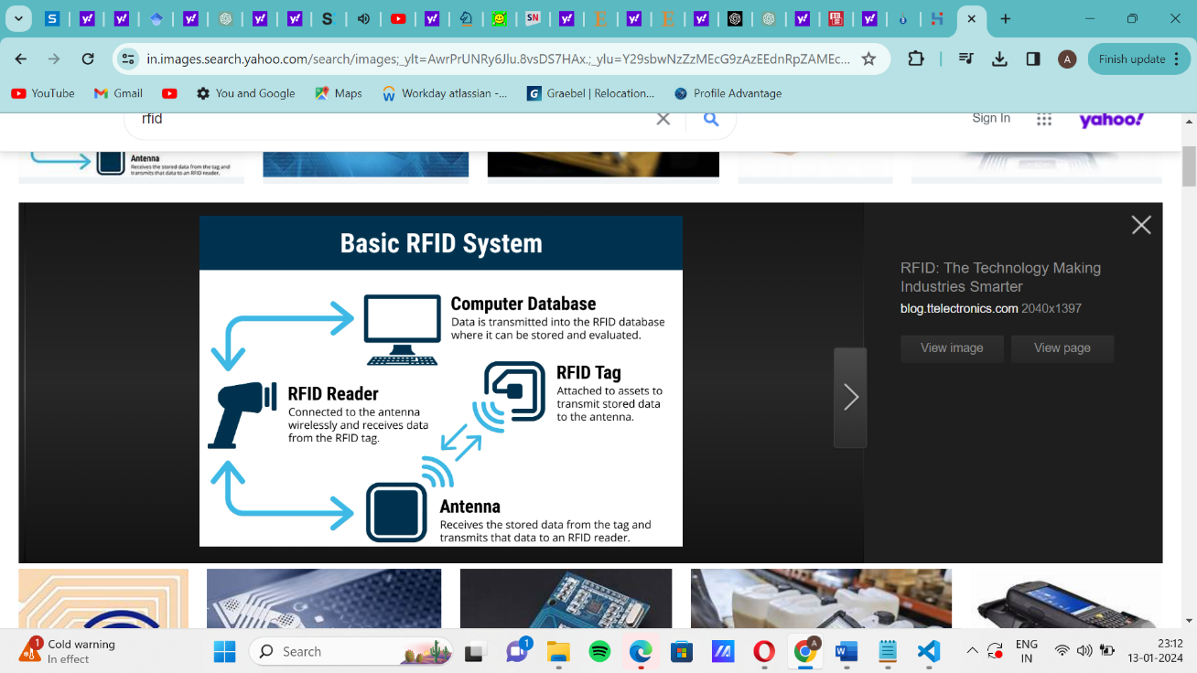

* **Blockchain without QR Codes**: Relying on blockchain technology for product traceability and authenticity verification without the user-friendly aspect of QR codes.
* **Colorimetric and fluorometric approaches:** It offers simplicity, cost-effectiveness, sensitivity, quantitative analysis, and applicability in diverse concentrations, ensuring reliable counterfeit detection
* **Physical Authentication Marks**: Using physical authentication marks like embossed logos or seals on products, which may not provide real-time validation.
* **Consumer Feedback Alone**: Relying solely on consumer reviews and feedback as a means of counterfeit detection without a systematic technological verification system.
* **Magnetic Stripes**: Implementing magnetic stripes on products for authentication, which can be less secure and easier to replicate than digital methods like QR codes.
* **Offline Verification Centers**: Establishing physical verification centers that consumers need to visit in person for product authentication, which is less convenient and accessible.
* **Security Labels**: Using security labels or stickers on products for authentication, which may not provide the same level of convenience as QR code scanning.

**2.5. Proposed Methodology**

In this “COUNTERFEIT DETECTION SYSTEM”, we will be having a QR code associated with the unique ID of product where while scanning, it will show various details about the company and the all the necessary information like whether the product is sold before or not, manufacturing place, manufacturer name, etc.

Here's how the Counterfeit Detection System works:

1. **QR Code Scanning**: As consumers prepare to make a purchase, they encounter a crucial checkpoint—the QR code affixed to the product. With a quick scan using their mobile devices, they initiate the process.



1. **Validation and Product Details:** The system springs into action, rigorously validating the QR code's authenticity. If the QR code checks out as genuine, users are seamlessly redirected to the official website of the brand, where a wealth of essential product details awaits. These details include a stamp of authenticity from the brand, the original price of the product, its current sold status, and insights into its supply chain journey.
2. **Informed Decision-Making**: Armed with this valuable information, consumers are empowered to make informed decisions about their purchase. If the product is confirmed as new and unsold, they can proceed with confidence, knowing they are acquiring an authentic item. On the other hand, if the QR code raises any doubts or the product has been resold, the system triggers an alert, both to the user and the concerned brand. This proactive approach serves as a powerful deterrent to counterfeit activity.

The various phases of this system are as follows:-

3.1 PHASE-1

Information about the product is fed at the backend of QR In this phase, the various details about the product like company name, brand name, characteristics of the product, size, color, price, etc. is being fed into the QR code. This would help the consumer to select the best product.

3.2 PHASE-2

Product is sold to the retailer by the company. In this phase, the product is sold to the retailer with the unique product ID associated with it. At this moment, the retailer is going to sell the product to the consumer at the price decided by the company itself.

3.3 PHASE-3

Consumer scans the QR code while buying in this phase, the consumer comes to buy the product. The consumer while buying, would scan the QR code and checks the details of the products. The consumer gets the various details of the product.

3.4 PHASE-4

If the QR code is not valid. In this phase, the QR code that is scanned by the consumer is not valid or it shows the status of product is sold before, it would automatically generate an alert to the company and the company would hold enquiry against the retailer and strict actions would be taken against the retailer.

3.5 PHASE-5

If the QR code is valid In this phase, if the QR code that is scanned by the consumer is valid , the consumer would be able to write reviews of the product. Hence then it would check against the replication of branded products.

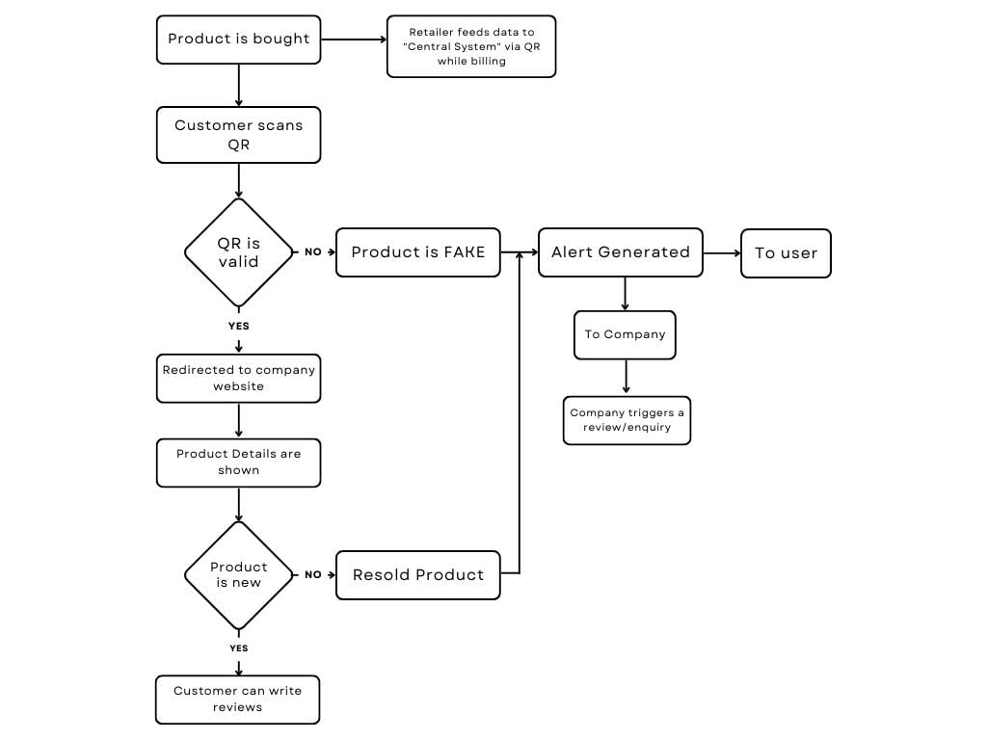

**4. CONCLUSION**

The proposed Counterfeit Detection System, centered around QR code technology, serves as a safeguard against counterfeit products. It empowers consumers to make informed purchasing decisions by providing real-time authentication and product information. By leveraging the strength of QR codes, consumers can easily verify the authenticity of clothing products, thereby ensuring their safety and protecting their trust in legitimate brands.

**4. REFERENCES**

### [An introduction to QR code technology](https://ieeexplore.ieee.org/abstract/document/7966807/)

[S Tiwari](https://scholar.google.com/citations?user=8BuQ2EgAAAAJ&hl=en&oi=sra)

2016 international conference on information technology (ICIT), 2016

### [2]. [A STUDY ON COUNTERFEIT BRANDS, CONSUMER ATTITUDE AND INITIATIVES TO STOP COUNTERFEITING IN INDIA](https://www.researchgate.net/profile/Ashok-Patel-27/publication/356085681_A_STUDY_ON_COUNTERFEIT_BRANDS_CONSUMER_ATTITUDE_AND_INITIATIVES_TO_STOP_COUNTERFEITING_IN_INDIA/links/618b815307be5f31b7623f0d/A-STUDY-ON-COUNTERFEIT-BRANDS-CONSUMER-ATTITUDE-AND-INITIATIVES-TO-STOP-COUNTERFEITING-IN-INDIA.pdf) AD VALOREM - Journal of Law: Volume 5: Issue II: April - June 2018: ISSN : 2348-5485

[3] Counterfeit detection with qr codes

J Picard, P Landry, M Bolay

Proceedings of the 21st ACM Symposium on Document Engineering, 2021

[4] THE IMPACT OF BRAND COUNTERFIETING ON CONSUMER BEHAVIOR IN THE FASHION SECTOR

[5] Extending the EPC Network – The Potential of RFID in AntiCounterfeiting Thorsten Staake, Frédéric Thiesse, Elgar Fleisch Report No. 27 20.10.2004

[6] The Economic Impacts of Counterfeiting and Piracy. International Chamber of Commerce, 2016

[7] IMPROVING FAKE PRODUCT DETECTION USING AI- BASED TECHNOLOGY

[8] Recent functional material based approaches to prevent and detect counterfeiting

[9] Detection of Counterfeit Product using Blockchain

[10] Counterfeit Integrated Circuits: Detection, Avoidance, and the Challenges Ahead

[11] Product Piracy Prevention: Product Counterfeit Detection Without Security Labels

[12] An RFID-based Anti-counterfeiting System

|  |  |  |  |  |  |
| --- | --- | --- | --- | --- | --- |
| **Author Name** | **Year** | **Methodology Used** | **Implemented (Yes/No)** | **Advantages** | **Applied on which Product** |
| Thorsten Staake, Frédéric Thiesse, Elgar Fleisch | 2004 | RFID Technology | Yes | RFID tags can incorporate strong cryptographic features, making them difficult to counterfeit or tamper with. | Any product includes Pharmaceuticals, Electronics, Clothing |
| Bora Yoon, Jung Lee, In Sung Park, Seongho Jeon, Joosub Lee  and Jong-Man Kim | 2013 | Colorimetric and fluorometric approaches | Yes | It offers simplicity, cost-effectiveness, sensitivity, quantitative analysis, and applicability in diverse concentrations, ensuring reliable counterfeit detection | Banknotes, pharmaceuticals, electronics etc |
| Kunal Wasnik, Isha Sondawle, Rushikesh Wani, and Namita Pulgam | 2022 | Blockchain Technology | Yes | The recorded data in a blockchain-based system is difficult to change without the consent of all parties concerned, making it extremely secure. | Electronics, Clothing Product etc. |
| Eduard Daoud, Dang Vu, Hung Nguyen and Martin Gaedke | 2020 | AI based Technology | Yes | It offers enhanced accuracy, efficiency, and adaptability to evolving counterfeit tactics | Pharmaceuticals, electronics, automotive parts, and documents. |
| Ujjwal Guin · Daniel DiMase ·  Mohammad Tehranipoor | 2013 | Electronic chip ID (ECID) | Yes | It employs unique identifiers and cryptographic techniques for secure authentication, providing real-time tracking and traceability. | Digital ICs |